Executing Program From Eclipse IDE:-

1.Unzip the zip file PigLatinTransmit.

2.Import the project PigLatinTransmit as a maven project into Eclipse IDE

3.Navigate to the file src/main/java/com/transalator/PigLatinTransalator.java

4.Right click on the file PigLatinTransalator.java and Select Run As -> Java Application

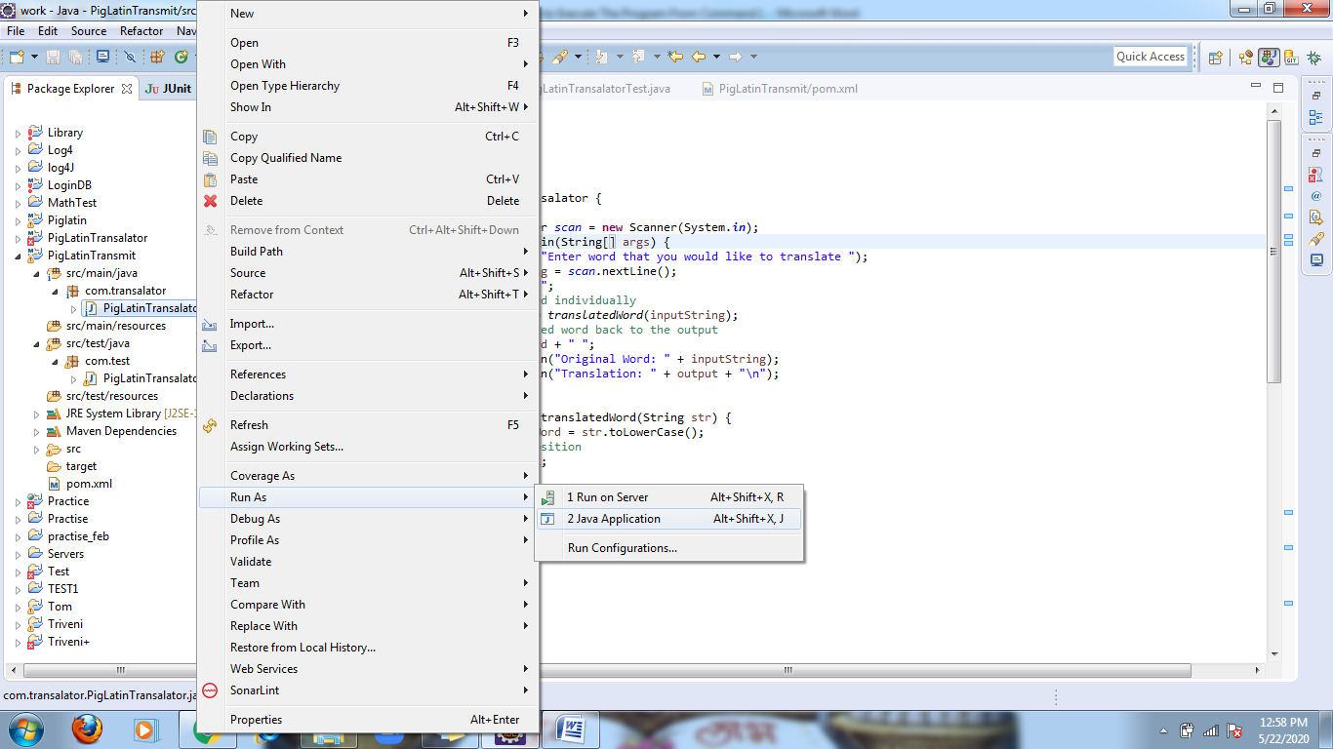

6.Enter the input in the console and see the output

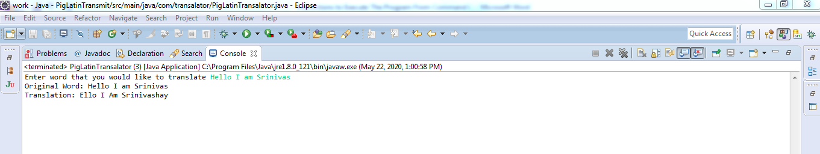

Executing JUnit Tests From Eclipse IDE

1.Right click on the  PigLatinTransalatorTest

2.Select Run As -> JUnit Test

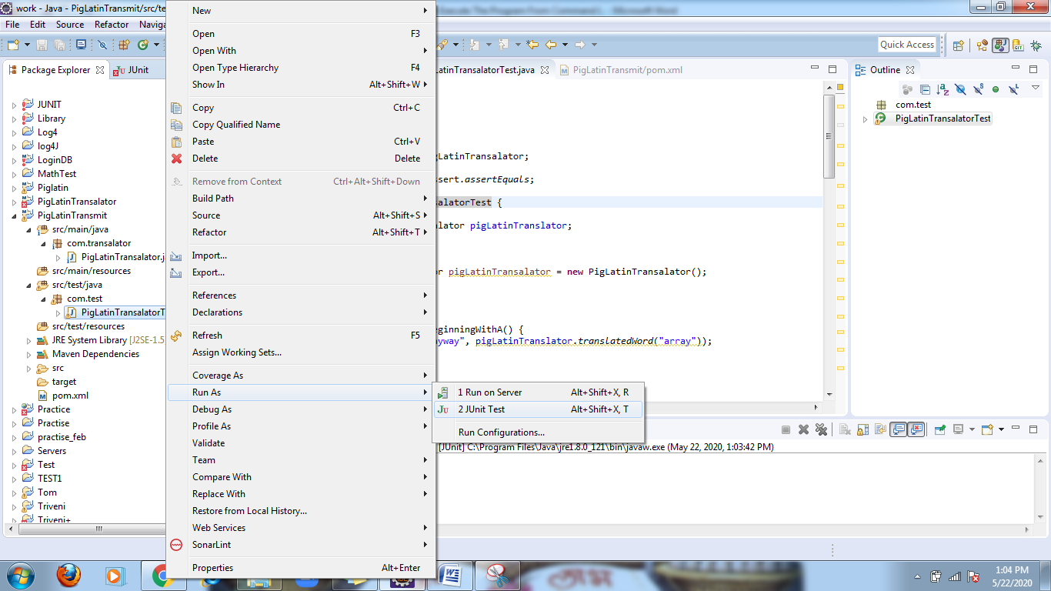

3.All the tests will be executed and the test result which is all positive and negative will be shown in the console

